# Acknowledgment

We like to acknowledge the opportunity provided by the Department of Electronics and Computer engineering to extend our theoretical knowledge into practical understanding through this project.

An attempt at any level cannot be satisfactorily completed without the support and guidance of skilled people. We would like to express our deep gratitude to Mr. Daya Sagar Baral, as well as our lab supervisors Mrs. Bibha Sthapit and Mr. Suresh Kafle for providing sufficient background knowledge and understanding of C++ language and very useful critiques of the project.

We are also thankful to all our colleagues of BEX 2074 who have willingly helped at some point in the project. We are always indebted to  
them for their kind support and constant encouragement and their enthusiasm to help us complete our project. Finally, we wish to thank our parents for their support throughout our studies and providing resource for the successful completion of this project.

# Abstract

The project of object-oriented programming is a Baghchal game. The intention behind the consideration of this project is to learn how to develop games with the most used language in the game development industry. Baghchal is believed to be around thousand years old originating in Nepal. It can be considered as a board game. It is generally played with grids carved on flat stones and different types of pebbles as tiger and goats in hilly regions of Nepal. This project focuses on developing a digital prototype of the Baghchal for computers by C++ language and object-oriented approach.

For this purpose, we started by familiarizing ourselves with all the rules of Baghchal and developing a plan on how to implement Baghchal rules by coding. We worked on flowchart of the program and then sketched out a model of a user interface. Then, we followed up with coding by C++ and the user interface was developed by SFML (Simple Fast Multimedia Library).

The project was done on Visual Studio. The game is fully functioning however, still there are some areas where improvements can be made so that the game would be more descriptive and more entertaining.

**Table of Contents**

Contents

Acknowledgment I

Abstract II

Table of Figures 2

1 Introduction 3

1.1 Rules for Baghchal 3

2 Objectives 4

3 Application 4

4 Literature Survey 5

5 Existing System 6

6 Methodology 7

7 Implementation 8

7.1 Flowchart 8

7.2 Block Diagram 9

7.2.1 For Pieces 9

7.2.2 For Board 10

7.2.3 For Bagh 11

7.2.4 For Bakhra 12

7.3 Documentation 13

8 Results 14

9 Problems Faced and Solutions 17

10 Limitations and Future Enhancements 17

11 Conclusion and Recommendations 17

12 References 18

# Table of Figures

**Figure 1: Baghchal in local place** 4

**Figure 2: Commercial Baghchal** 4

**Figure 3: Start of Game** 12

**Figure 4: Gameplay** 13

**Figure 5: Winner Screen** 14

# Introduction

Baghchal is an ancient hunt board game from Nepal. Its name means "moving tigers", and is played by two players, one controlling four tigers, the other controlling twenty goats. The game is played on a 5×5-point grid. Pieces are positioned at the intersection of the lines and not inside the areas delimited by them. Directions of valid movement between these points are connected by lines.

## Rules for Baghchal

1. The game begins with four tigers on the board, one in each corner.
2. The goat player takes the first turn.
3. If the goat player has goats in hand, he must use his turn to place one on any empty point on the board.
4. If the goat player has placed all the goats, then he must instead use his turn to move one of the goats from its current position, along a marked line in any direction, to an adjacent empty point.
5. The tiger player in his turn may move a tiger from its current position, along a marked line in any direction, to an adjacent empty point.
6. Only one piece may occupy a point at any one time; stacking of pieces is not allowed.
7. A tiger may sometimes capture, or eat, a goat, the tiger player must jump with one of his tigers along a marked line, over an adjacent goat, to an empty point beyond. The goat is then removed from the board and takes no further part in play.
8. The tiger may not change direction in the middle of its jump. A goat is only in danger of being eaten if on one side it has a tiger, and on the other an empty space.
9. Only one goat may be eaten in any one turn. Multiple jumps are not allowed.
10. The tiger player wins when his tigers have eaten five goats.
11. The goat player wins if the tigers are trapped and the tiger player has no legal move.

# Objectives

Following were the intentions behind going ahead with this project:

* To become familiar with the basic concepts of OOP such as classes, objects, inheritance, polymorphism etc and implementation of the OOP.
* To learn about third party library features that can be used with C++.  
  We aim to implement these library files to enhance our project and our  
  knowledge.
* To gain valuable experience and knowledge on design of games. The project will familiarize us with the game development cycle.
* To learn more things about GUI and their use in our CUI based  
  coding in order to create an intuitive program that matches today’s standard.
* To give a digital identity to Baghchal game which is not so popular with the new generation.
* To gain experience on group cohesion and work division.
* And to get familiar with collaboration tools of coding projects.

# Application

Some applications of this project are listed as below:

* Enjoy a great game on the new and best computerized way.
* It is suitable for all age people for entertainment and time pass.
* It can be a great tool to improve strategy developing skills.

# Literature Survey

Baghchal is believed to be originated in hilly regions of Nepal about thousand years ago. This game is said to be played by Shepherds in villages of Nepal on a grid scrapped into dirt with stones used as tigers and pebbles symbolizing goats. The game is very easy to setup so the game can be played anywhere. This game is also popular in southern India with a different board, but the rules are the same.

The gameplay is more similar to other board games like Alquerque, Checkers or Draughts It is a game played between unequal forces with different goals. If the goats are not clever, they make an easy meal for the hungry felines. A Baghchal game can be as short as 5 min & as long as 1 hr. Expert players can trap tigers even before placing all 20 goats in board Baghchal.

It is mentioned as national game of Nepal in various international platforms. However, it is slow but steady decline.

# Existing System

These days it is generally played by drawing grids wherever it is possible and using stones and pebbles as tigers and goats respectively.

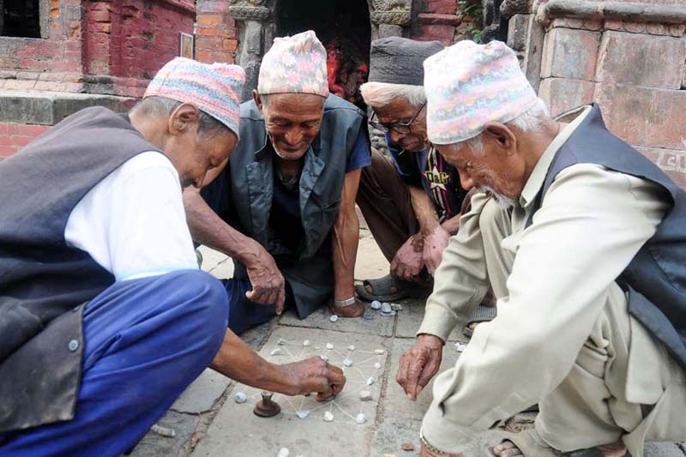

**Figure 1: Baghchal in local place**

Also, the Baghchal grid is carved into a wooden or brass game box to sell to tourist. The etched brass sheeting displays a decorative gridded 5×5 point board with a compartment within the wooden frame holds the small brass tigers and goats.

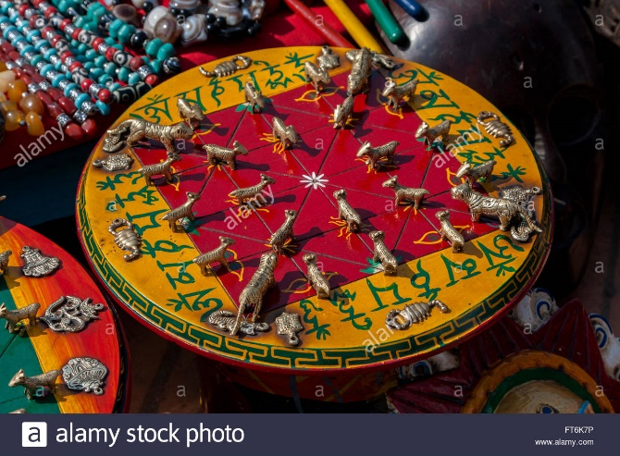

**Figure 2: Commercial Baghchal**

There are many Baghchal games developed by other programming languages. But we are mainly focused on making this game with object-oriented concepts using C++ programming languages.

# Methodology

For completing this project successfully, one should have the clear knowledge and understanding of C++ programming language. Mainly creating a project like Baghchal game, we should have the logics behind the playing of the game and the knowledge of C++ graphical library. There are many codes which are available in various platforms in internet which were very helpful for us to complete this project.

For the completion of this project we are went through the many books and articles written on C++ programming language by different authors. We also discussed ideas with our classmates and we implemented the best ideas given by them also. We went through the various tutorial videos especially on using graphics in C++ on internet portal. The linking of the various header files and standard library were used to provide the more additional features to the game.

Our Baghchal game is mainly focused on providing the user-friendly gaming environment to our users. On making this project a grand one, we decided to divide this complete project work among our members so that no one will miss out in this knowledge gaining phase.

Firs task was writing the source code, then merging it wholly, testing and debugging, finalizing the code and at last documenting the project.

# Implementation

## Flowchart

Start

Picked Goat=0

Dead Goat=0

No

Is Picked Goat<20

Move Goat

Yes

Place goat

d

Picked goat= Picked goat + 1

Yes

Is tiger blocked?

Winner is Goat

Move tiger

No

Does tiger eat goat?

Yes

Dead goat= Dead goat+1

No

Is dead goat=5?

Yes

Winner Tiger

## Block Diagram

### For Pieces Class

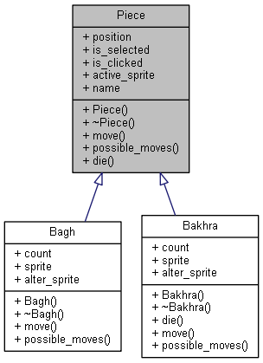

### For Board Class

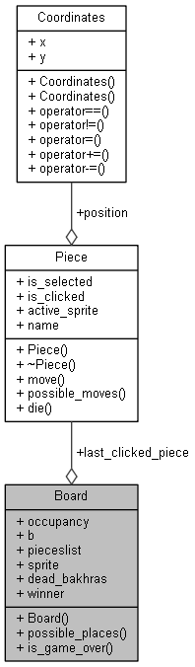

### For Bagh Class

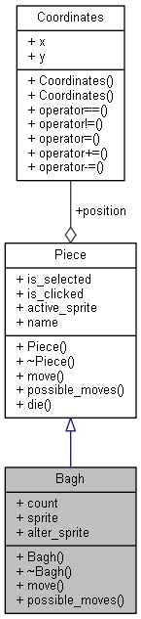 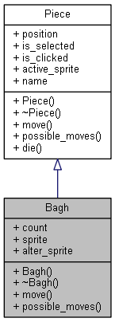

### For Bakhra Class

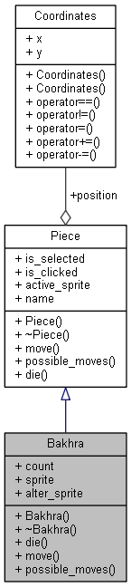 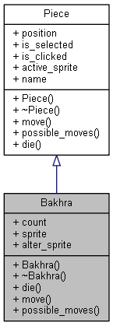

## Documentation

Documentation is also an integral part of a software project. We have done the documentation of the Baghchal game using Doxygen software. By documentation, anyone can now understand the program flow of the project easily. It would be very useful for further improvement in near future.

# Results

A Baghchal game with user interface was compiled and ran successfully. Following are some glimpses of the game:



**Figure 3: Start of Game**

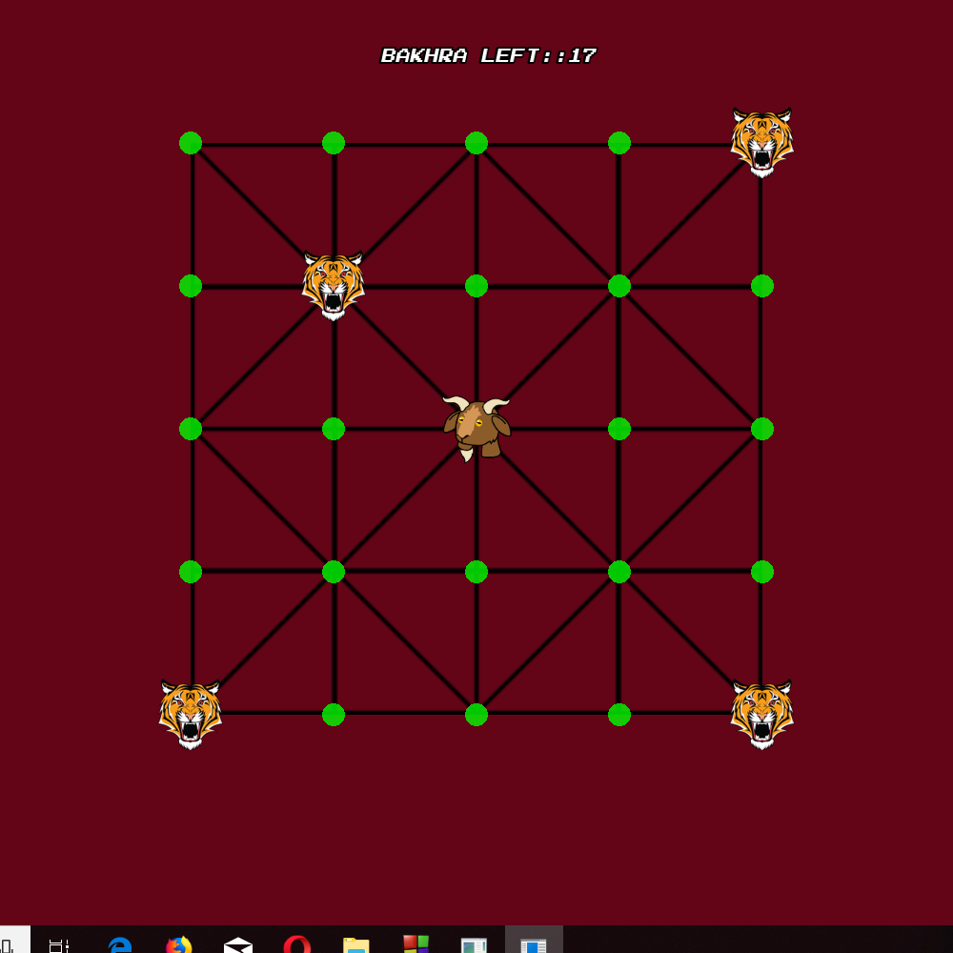

**Figure 4: Gameplay**

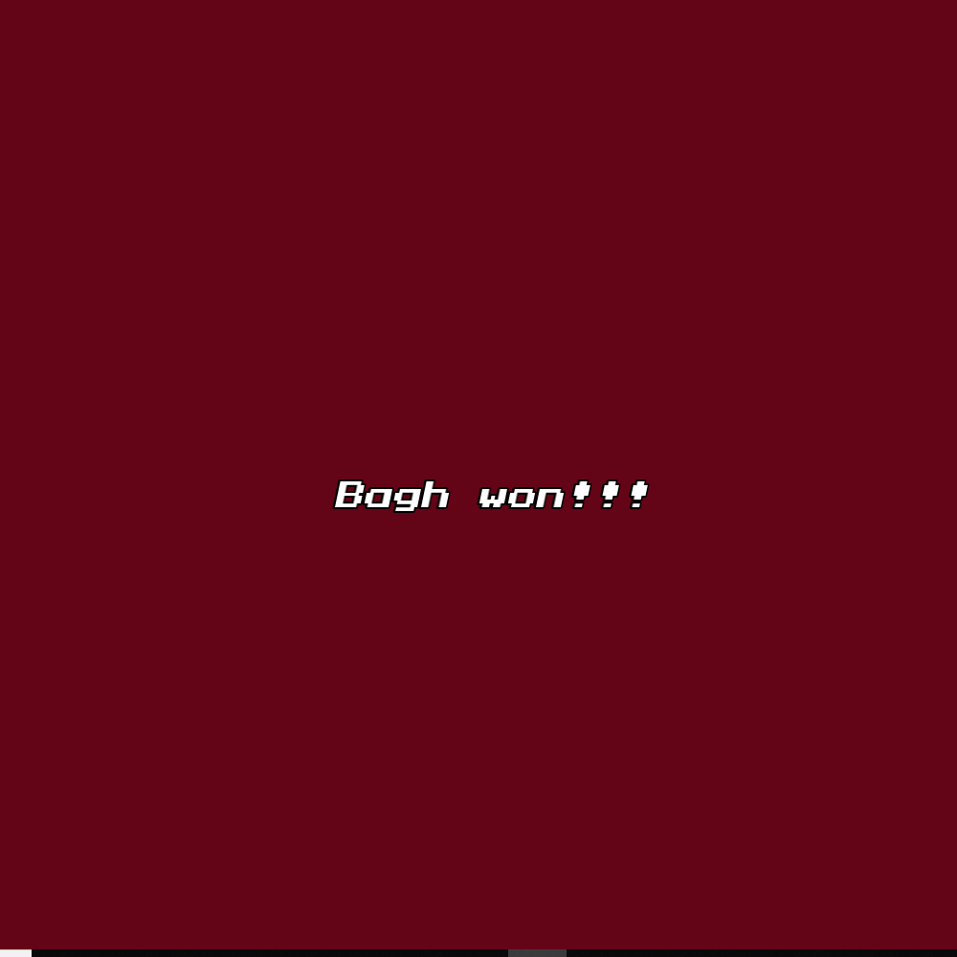

**Figure 5: Winner Screen**

# Problems Faced and Solutions

We had to cope with the following problems for the completion of the project:

* During the project, we as a team had difficulties while collaborating in coding stage as we were unfamiliar with the coding tools.
* Learning graphics library in short period of time was challenging.
* It was difficult to develop a user interface that matched the gameplay of real Baghchal game.

As the project went on, we got comfortable with the collaborating tools. We only learned the graphics library as per required in the project rather than learning the use of whole library. We consulted local elders about on how the user interface should look like and went ahead with their suggestion.

As in every coding project, there was some compile, runtime or logical errors which we dealt throughout the project.

# Limitations and Future Enhancements

Our game is just a though the popular grid is 5x5, there are other types of grid as well which we could not incorporate here. Both players should play form the input of same mouse.

It can be made an online game where two players can play from different computer. Text and voice chatting can be added in the online version.

# Conclusion and Recommendations

Hence, the project was completed and now a battle between two masterminds can be enjoyed. As a whole, project was a good learning experience and came face to face with practically applicable aspect of engineering which may guide us in developing professional projects in near future.

Meanwhile, it would provide a good basis for us, the programmers to work on big projects in near future. But most importantly, we came to a conclusion that C++ is a powerful language and object-oriented programming is definitely a better than approach to map real world entities into programs.

# References

* Baral, Dayasagar. “The Secrets of Object Oriented Programming in C++”. Bhundipuran Prakashan. November 2010.
* Deitel, Paul.” C++ How to Program”. Prentice Hall. 2012
* [www.stackoverflow.com](http://www.stackoverflow.com)
* [www.dsbaral.com.np](http://www.dsbaral.com.np)
* [**w**ww.github.com](http://www.github.com)
* [www.youtube.com](http://www.youtube.com)
* [www.wikipedia.com](http://www.wikipedia.com)
* [www.google.com](http://www.google.com)